# Code Documetation for project NameSorter

# Created by: Dedy Wijaya

# Date: October 11, 2018

1. Code Logics

Assumption: Every name at has First Name and Last Name. It can have second and third name.

In the main function there are 4 steps to complete the task

1. Read the input of names from the file

…

Scanner s = **new** Scanner(**new** File(args[0]));

ArrayList<String> people = **new** ArrayList<String>();

**while** (s.hasNextLine()) {

String people2 = s.nextLine();

people.add(people2);

}

s.close();

…

1. Sort the input of names from the file by passing a custom comparator, LastNameOnlyComparator.

…

Collections.*sort*(people, **new** LastNameOnlyComparator());

…

1. Display the sorted names on the screen

…

**for** (String person: people) {

System.***out***.println(person);

… }

1. Write the sorted names to a file

…

BufferedWriter writer = **new** BufferedWriter(**new** FileWriter("C:\\Users\\dedyw\\eclipse-workspace\\SortingByLastName\\src\\sorted-names-list.txt"));

**for**(String str: people) {

writer.write(str);

writer.newLine();

}

writer.close();

…

For the custom LastNameOnlyComparator there are 2 steps to implement the Comparator’s compare Interface;

1. Split the name to compare by empty space.

…

String[] arr1 = s1.split(" ");

String[] arr2 = s2.split(" ");

…

1. Compare the last name found from the splitting step

…

**if** (arr1.length > 1 && arr2.length > 1)

**return** arr1[arr1.length-1].compareTo(arr2[arr2.length-1]);

**else**

**return** 0;

…

1. Running the codes
2. By using Eclipse

* - Download and install eclipse from

<https://www.eclipse.org/downloads/>

* Put the files as shown on your working folder, the files you can download from :

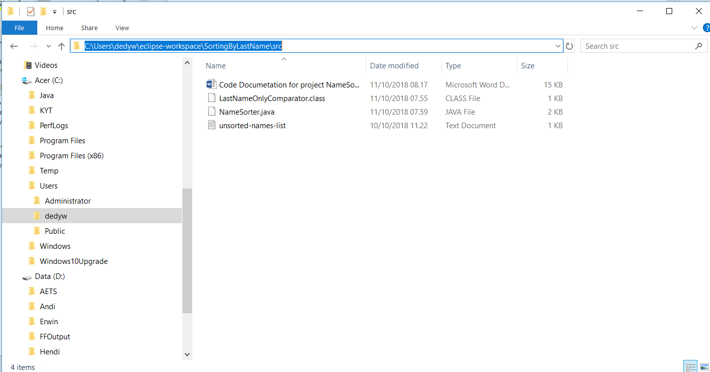

* Open the NameSorter.java as project.
* Go to Run 🡪 Run Configurations select the Arguments tab and put the directory where the unsorted-name-list.txt file is stored, as follows

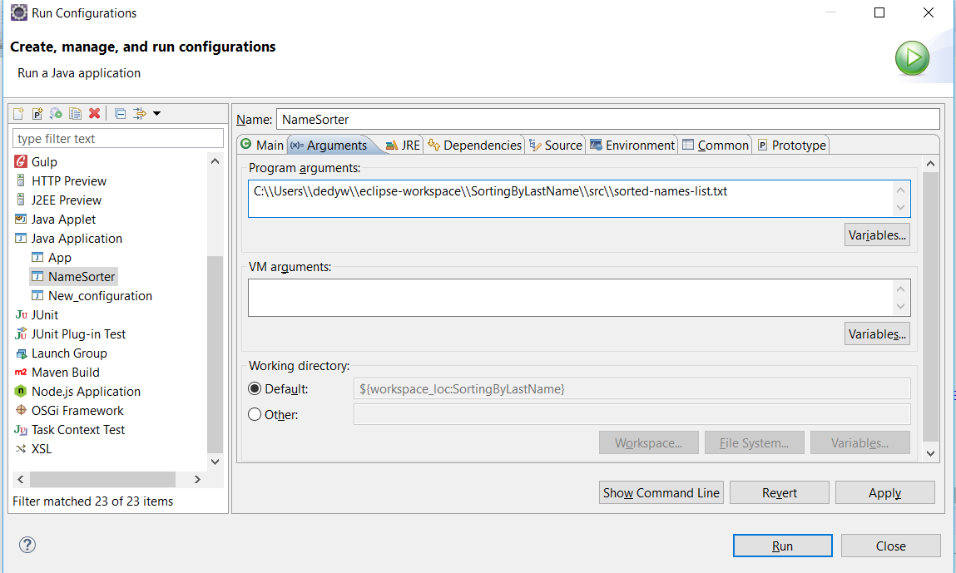

* Click Run

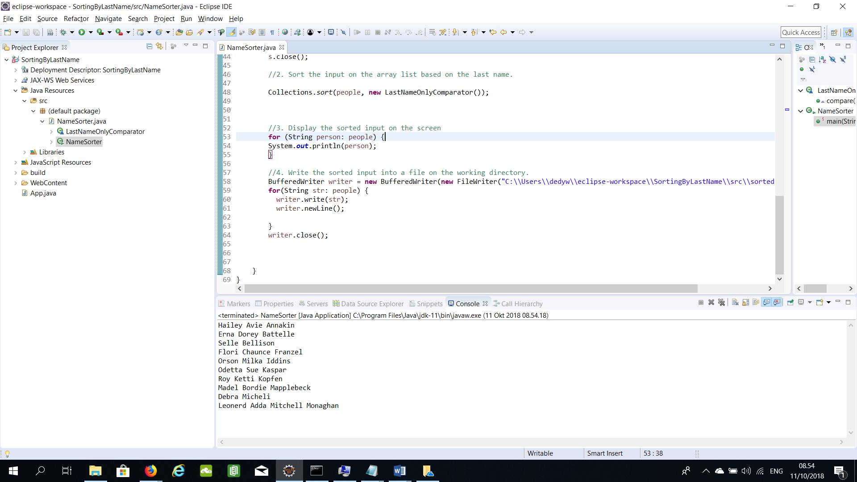

1. By using command prompt

* Make sure the installation of jdk1.8.0_181 and jre1.8.0_181 are done.
* Make sure the environment variable JAVA_HOME is set up to jdk1.8.0_181 bin folder , for e.g.

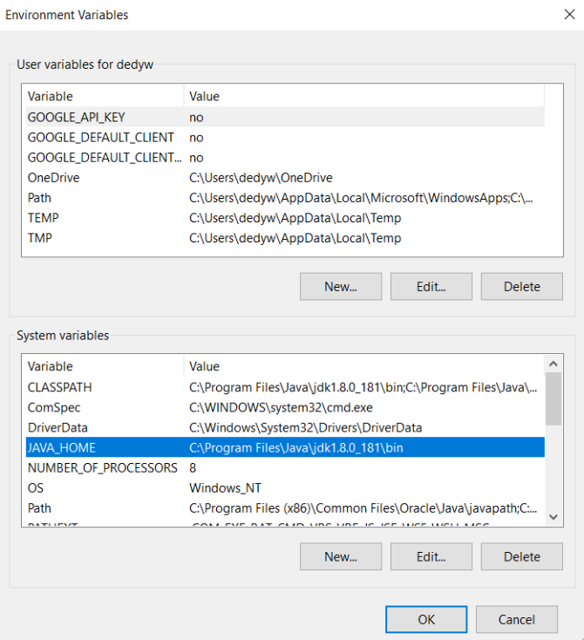

* Make sure the Path is set up to jdk1.8.0_181’s and jre1.8.0_181’s bin folder, for e.g.

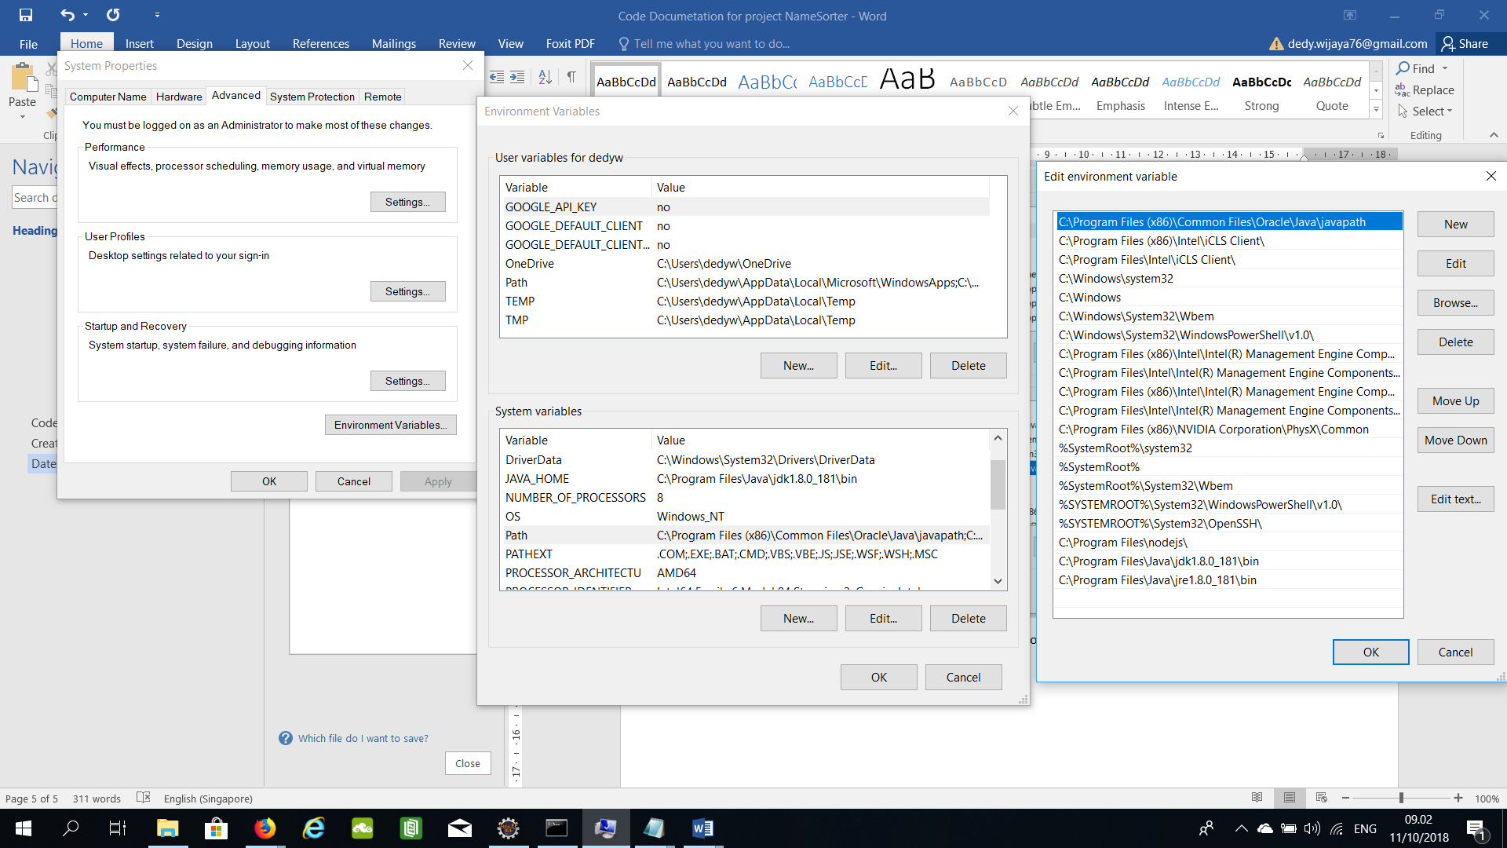

* Make sure the CLASSPATH is set up to jdk1.8.0_181’s and jre1.8.0_181’s bin folder, for e.g.

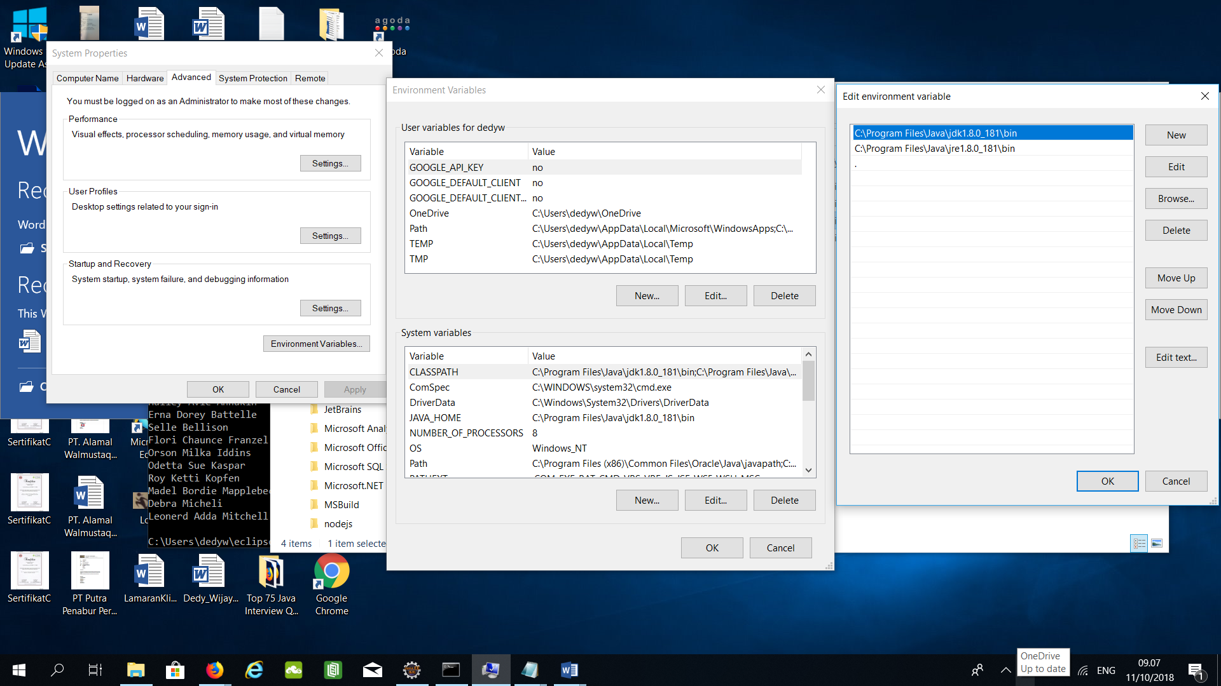

* Open the command prompt
* Go to the working folder

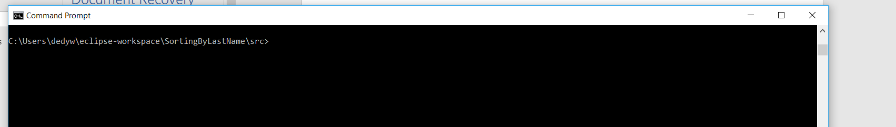

* Compile the NameSorter using javac command

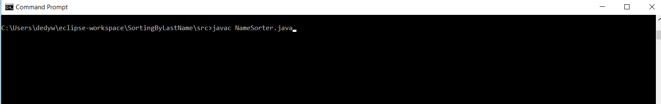

* Run the compiled NameSorter.class, as follows



* Check the results on the screen

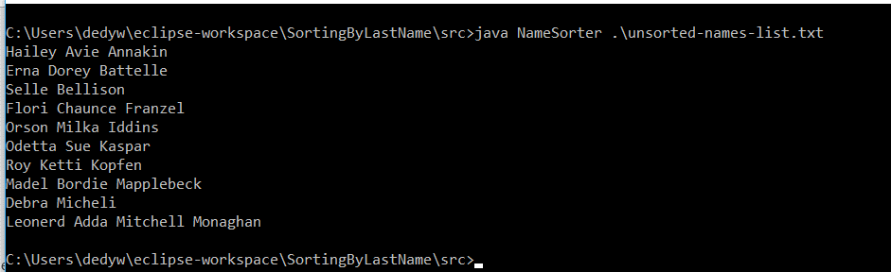

* 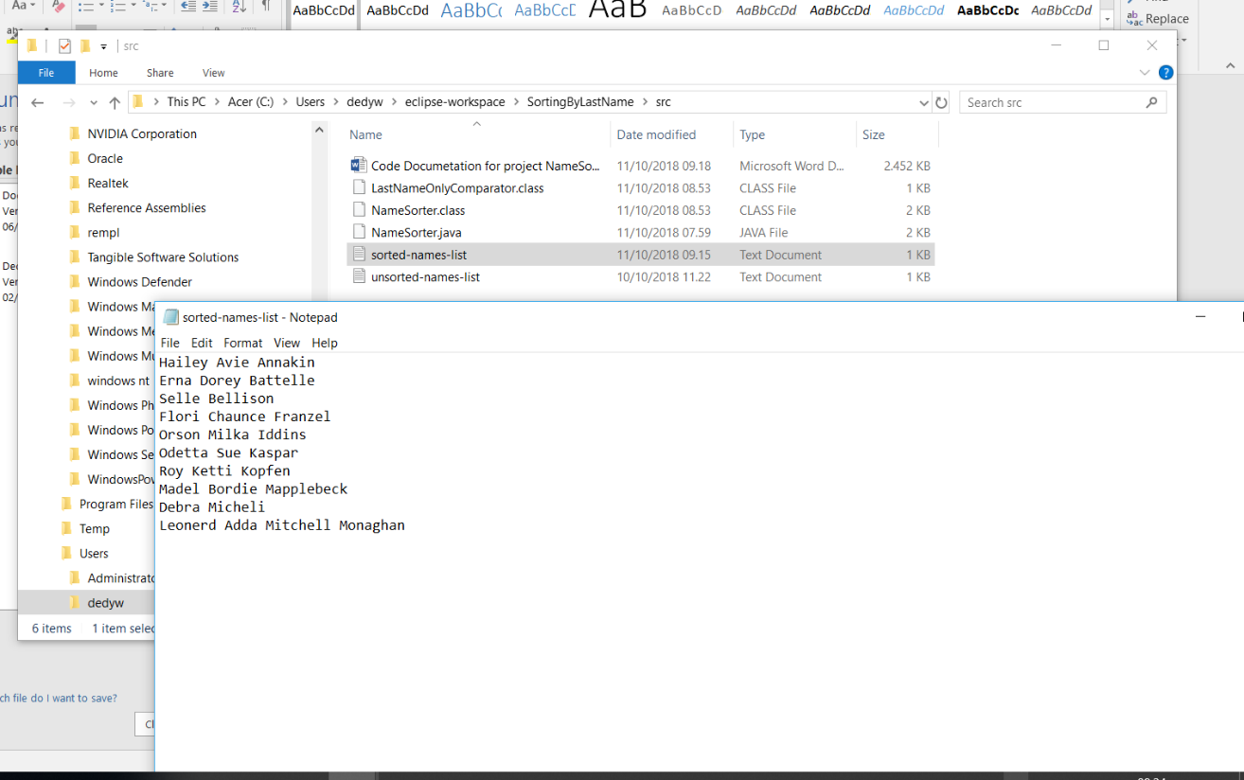Check the results on the file sorted-names-list.txt